**Guide to run MAT Software Team Coding Challenge**

1. Use an Ide. For example download IntelliJ if needed in <https://www.jetbrains.com/idea/> ;
2. Go to **File>Open** and select the pom file: ‘*pom.xml*’;

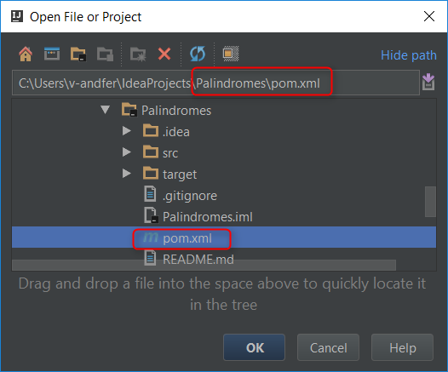

1. To run the main program, go to **PalindromesMain.java**

Please see below an example where to find *PalindromesMain.java*, the button to Run the program and the place to change the Input String

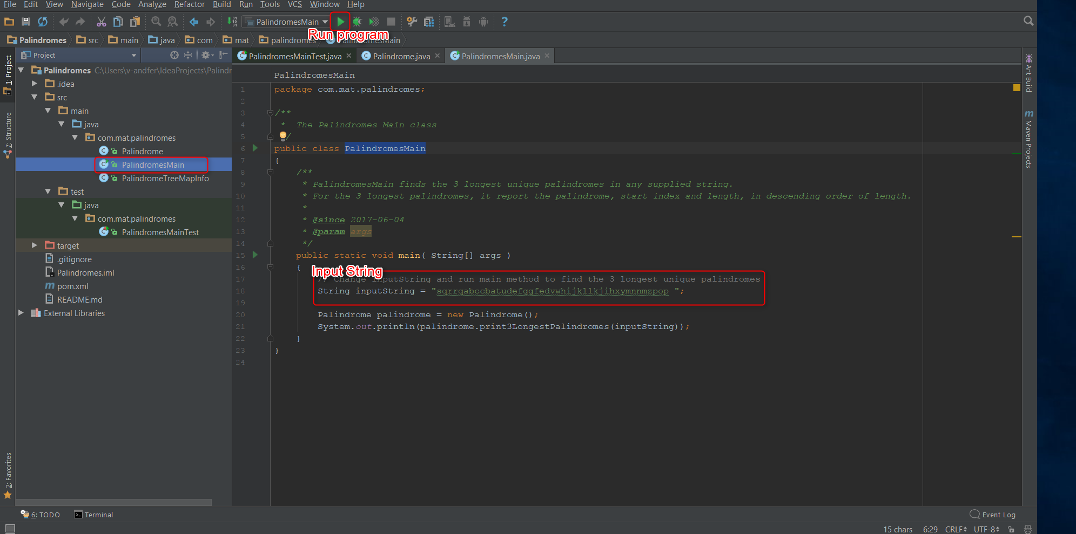

1. As an example, we are going to test with the Input String: ‘**sqrrqabccbatudefggfedvwhijkllkjihxymnnmzpop**’.

Please see picture below:

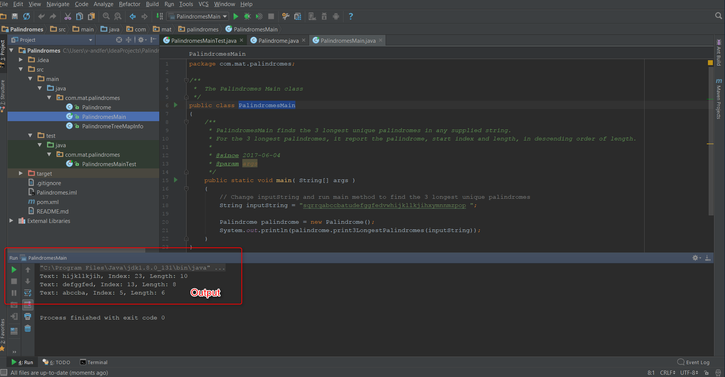

1. Junit tests were used to verify the correctness of a program's behaviour (see PalindromesTest.java);

If you need any help running the code, please send an email to: [andresalvador_@hotmail.com](mailto:andresalvador_@hotmail.com)

I’ll gladly help you.